Lightcycler 480 qPCR machine

Log on name: admin

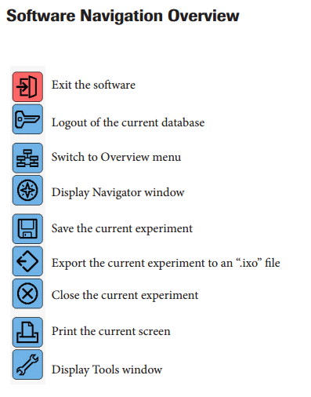Password: Master1

* Click on ‘New experiment from Template’
* Choose a template to adapt, eg Sybr Green template
* Click on each part of cycle to change as appropriate
* Click drop down menu on bottom left of page and ‘Save as template’
* Choose folder and name then click on button and it will save
* When ready, insert plate into side of machine and Start Run button will come unshaded. Click to start run

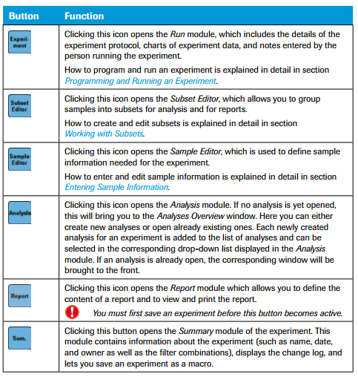

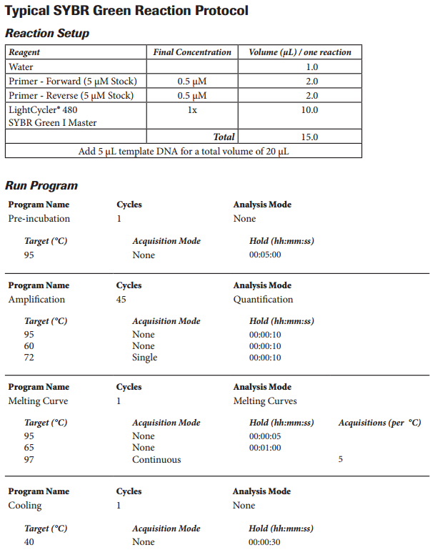

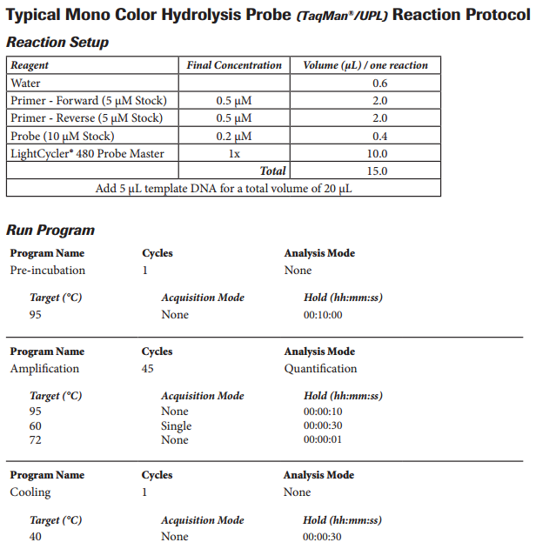

**Analysing Data**

Go to your folder (or System Admin if you didn’t save experiment in your folder) and then ‘Experiments’ folder ->

Open

Click ‘Analysis’

Choose Absolute quantification/2nd Derivative from dropdown

Click on tick

Page opens and click ‘Calculate’ bottom left and your Cp values will appear in table

Export these to Excel as these are the values you will analyse

Click on wells you want to compare – always good to have a look at negative control first.

For standards -> there should be a difference in Cp value of 3.3 between each dilution factor of 10. If not then there was some error in your dilution

**Melt Curve Analysis:**

In ‘Analysis’ dropdown menu at the top, choose ‘melt curve’

Real value (light emission) in top graph

Derivative in second graph. This shows different peaks corresponding to temperature at which different sequences of DNA disassociate and become single stranded.

(Different sequences and different lengths of sequences give different peaks).

If primer dimers are present there will be a peak in the negative controls (have a few replicate –Cs to check that it’s primer dimer and not contamination).

You can use the information provided by this peak to choose a better temperature at which to take your fluorescence reading each cycle.

In other words, choose at temp at which all your primer dimers have disassociated, but your sample has not yet disassociated. (normally around 81°C)

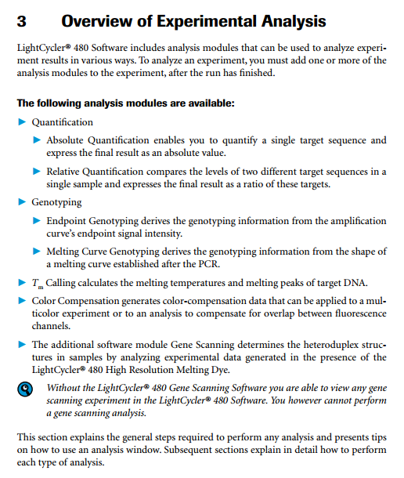

# Cycle used by Cindy’s lab for Sybr Green qPCR:

|  |
| --- |
| C:\Users\13233148\Downloads\IMG_20151126_143813665_HDR.jpg |
|  |
|  |